Paper Тitle

Name Family, Name Family, Name Family
Affiliation, City, Country
Abstract: The text should be between 5 and 10 lines long, has to be written as „Abstract“ format, Arial 11 pt, italic, single line spacing, justified.
Keywords: Should be 1-2 lines, „Keywords“ format, Arial 11 pt, italic, single line spacing, justified.

INTRODUCTION
The heading „Introduction“ has to be written as „Introduction“ format, Arial 11 pt, single line spacing, 36 pt spacing before and 6 pt spacing after the capital letters.

File SAVING
All headings have to be written as „ Heading 1“ format, Arial 11 pt, single line spacing, 24 pt spacing before and 6 pt spacing after the capital letters.

Save file as
Please save your file with the following denomination „Family name, Paper title“ with maximum 40 characters long.

Third level headings
The paper should be no longer than 6 pages.

Format

Margins
The margins of the B5 pages are: top 3 cm, bottom 2,5 cm, inside 2,5 cm, outside 2 cm, mirror margins.

Title and Author
The Title has to be written as „Paper title“ format, Arial 16 pt, bold, single line spacing, centered.
The Authors have to be written as „Author“ format, Arial 12 pt, bold, single line spacing. In the case of more than one Author of the same affiliation they have to be separated by a comma. The maximal number of different affiliations is two.
The affiliation has to be written „Affiliation“ format, Arial 11 pt, italic, single line spacing.

Headings
Each heading level has to be written in the following formats:
- Heading 1. Level: as „Heading 1“ format
- Heading 2. Level: as „Heading 2“ format
- Heading 3. Level: as „Heading 3“ format

Text
Each paragraph in the same Heading has to be written as „Normal text“ format. These settings are Arial 11 pt, single line spacing, justified and the first line is indented 0.7 cm. Please do not format the text with italics, bold or underlined. Please do not use more than one space between two words.

Enumerations
Please use the „Listing“ format while enumerating in the text.
- Germany
- Switzerland

Tables and Figures
The text in the Tables has to be written as „Table text“ format. These settings are Arial 10 pt, single line spacing and right-justified. Please do not format the text with italics, bold or underlined. The Table lettering is always above the Table and eventually Table explanations are below the Table. Please use the pattern Tab. 1 for building the Tables. Here is valid the „Table caption“ format, Arial 10 pt, single line spacing:

Tab. 1: The word „Table“ is abbreviated as „Tab.“.
Solar region ¹ | Direct, W/m² | Diffuse, W/m² | Total, W/m² | Daily, kWh/m²
Sofia | 510 | 210 | 720 | 5.45
Blagoevgrad | 600 | 200 | 800 | 6.21
Sandanski | 655 | 230 | 885 | 7.56
¹ In Bulgaria

Figures have to be written as „Figure caption“, Arial 10 pt, single line spacing. The Figures lettering is always below the respective Figure.

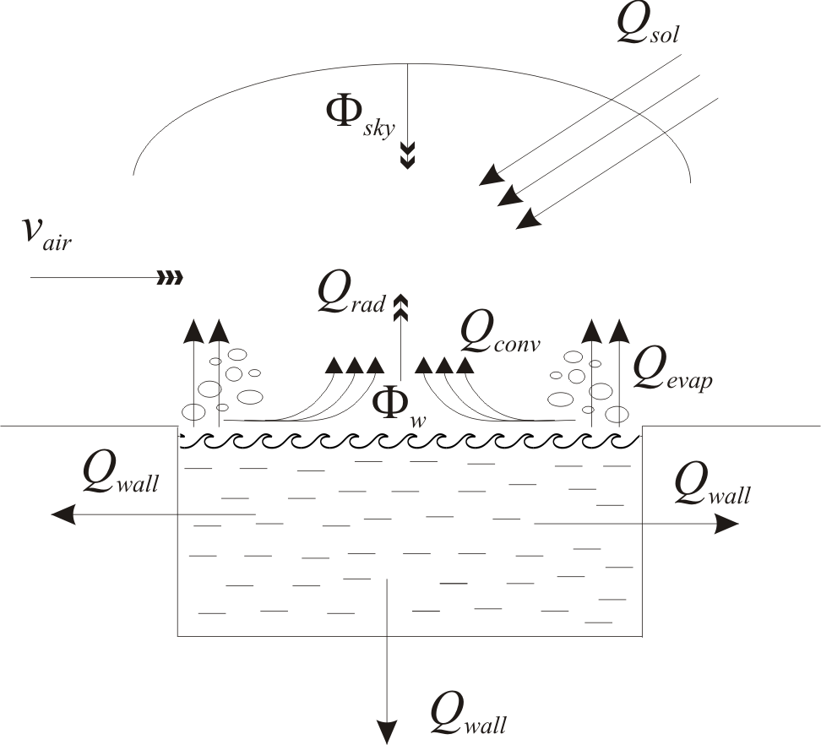

Fig. 1: The word „Figure“ is abbreviated as „Fig.“.

Figures and Photos must be included in their original sizes in one of the following graphic formats: pcx, eps, tif or jpg. The minimal resolution for Photographs should be 300 dpi, as well as 1200 dpi for Diagrams and Charts.
All Photos and Figures must be provided in black & white. Colour illustrations are not accepted, as the Proceedings Book will be printed in black & white. All Tables and Illustrations should be numbered consecutively in the order to which they are referred.

Equations
All equations must be written with the „Formula“ format, Arial size 12 pt, single line spacing. All equations should be numbered at the left side of the text line, and should be referred in the text according to this number. For example:
(1) $c=c_{1}\frac{K_{D}(Т_{w^{2}}−Т_{D})}{Z}$
Please use the international S.I. units:
- Mg, Kg, m, kJ, cm, etc.
- 9.000 instead of 9000

References
The referencing in the paper to literature sources should be indicated by figures in square brackets.

material SUBMISSION to the editor
A printable Word document as well as extra annexed photos or illustrations in eps, tif or jpg formats must be delivered to the Editor within the date limit. Late delivered papers cannot and will not be further edited!
Please note that, due to the uniform layout of the conference proceedings, only the papers formatted according to this template can be accepted.

Results, discussions, CONCLUSIONS
Page must not be numerated.

references
All references will be included at the end of the paper in alphabetical order of the surnames of the first author and must follow the bibliographic IEEE standards of journals. References should be formatted with the „Reference“ style, Arial size 12 pt, single spacing. The rules for referencing Books and Journals are presented as follows:
- Last name, Initials (ed.) (Year) Book Title. City; Country: Publisher.
- Last name, Initials (Year) Title of the Articlre. Title of Journal (ISSN) Volume number, Page numbers.
Examples:
- Duffie, J.,Beckman, W. (1980) Solar engineering of thermal processes, New York, Wiley Interscience.
- Csordas, G., Brunger, A. (1992) Plume entraintment effects in solar domestic hot water systems employing wariable-flow-rate control strategies, Solar Energy 49 (6), 497-505.

